# Download, Install and configure terraform, VScode, AWS CLI and authentication terraform with AWS using AWS Access key

# **To Download, Install and configure terraform and Visual studio code.**

## -Download, Install and configure terraform:

To download terraform by using the following link:

- <https://developer.hashicorp.com/terraform/downloads>

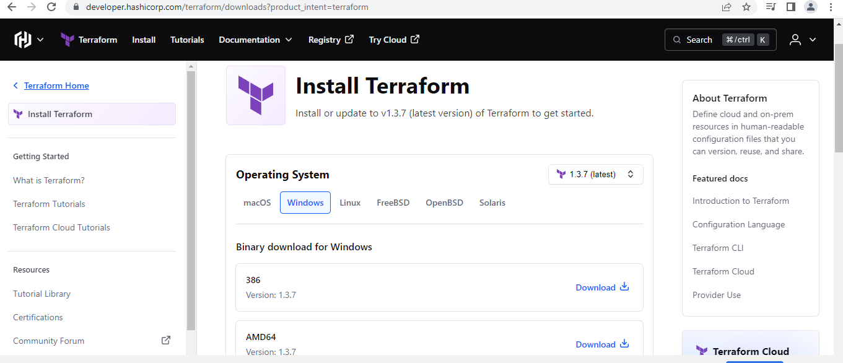

To create a folder terraform in c:>program files:

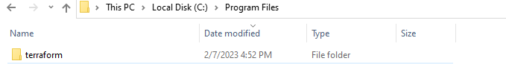

Terraform.exe file extract to terraform folder:

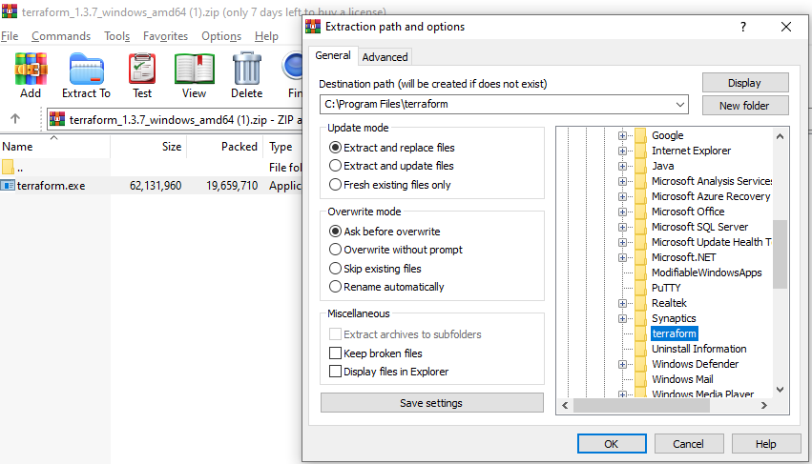

To check the executable file in c :> program files>terraform:

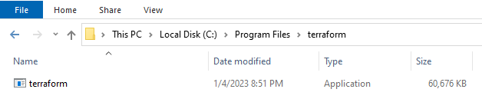

## -Add the environment variable: Path- C:\Program Files\terraform

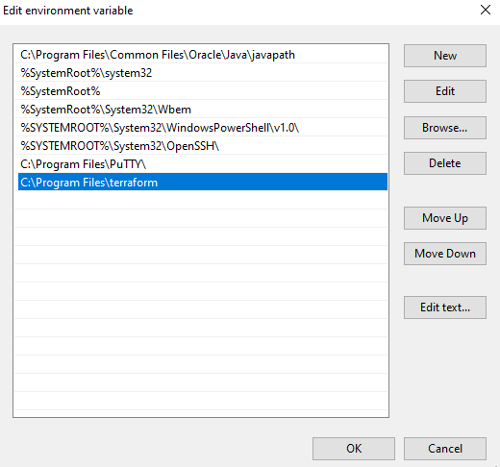

## -Open command prompt and check the terraform version by using the following the command:

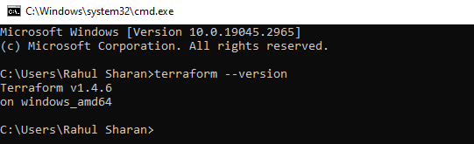

## -Download, Install and configure Visual studio code:

To download Visual studio code by using the following link:

-https://code.visualstudio.com/download

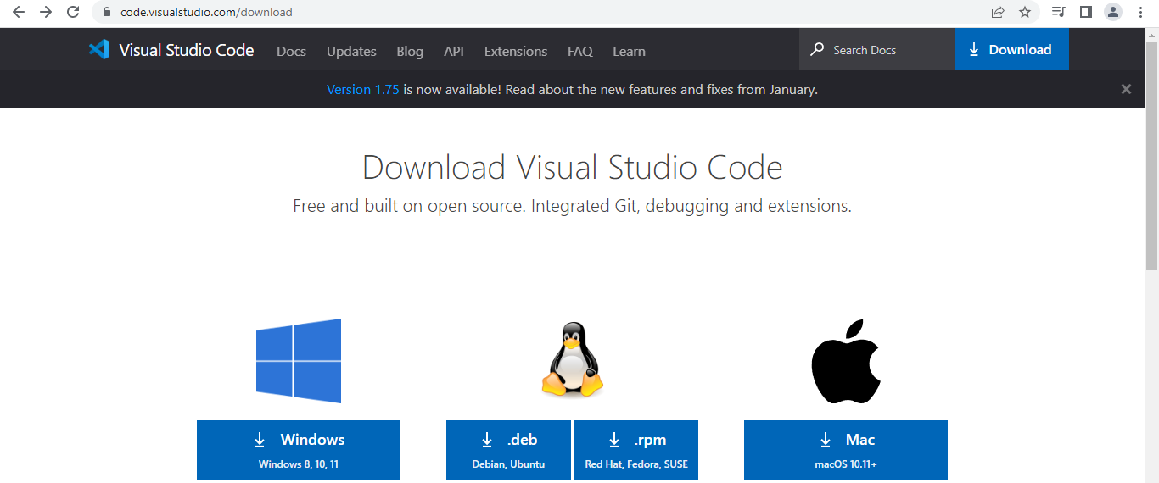

To install Visual studio code:

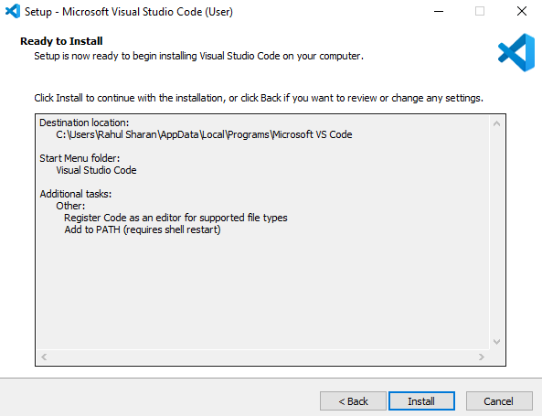

## -Add extensions in VScode -terraform and AWS terraform:

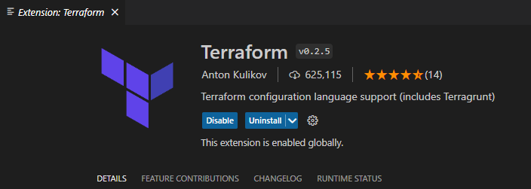

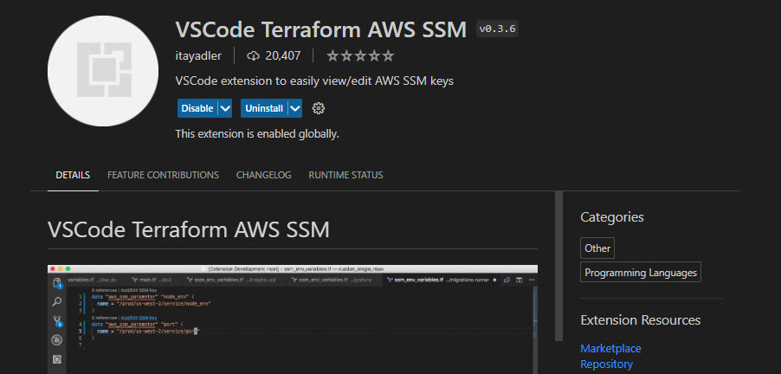

# **To Authentication terraform with AWS using AWS Access key:**

## -Download and install the AWS CLI for windows by using the following link:

<https://docs.aws.amazon.com/cli/latest/userguide/getting-started-install.html>

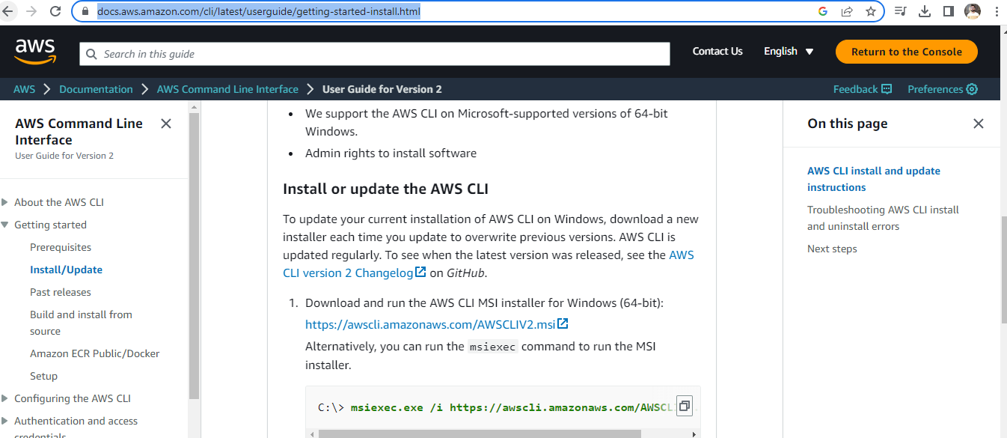

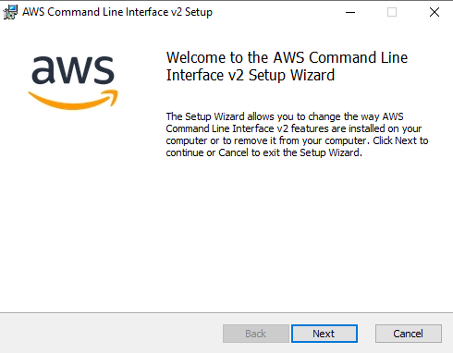

## -Check the Aws version on windows m/c:

Open the command prompt and check the Aws version by using the following command:

>aws --version

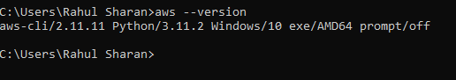

## -Create Access Key using IAM service:

IAM>Security Credentials>Access key: Create access key.

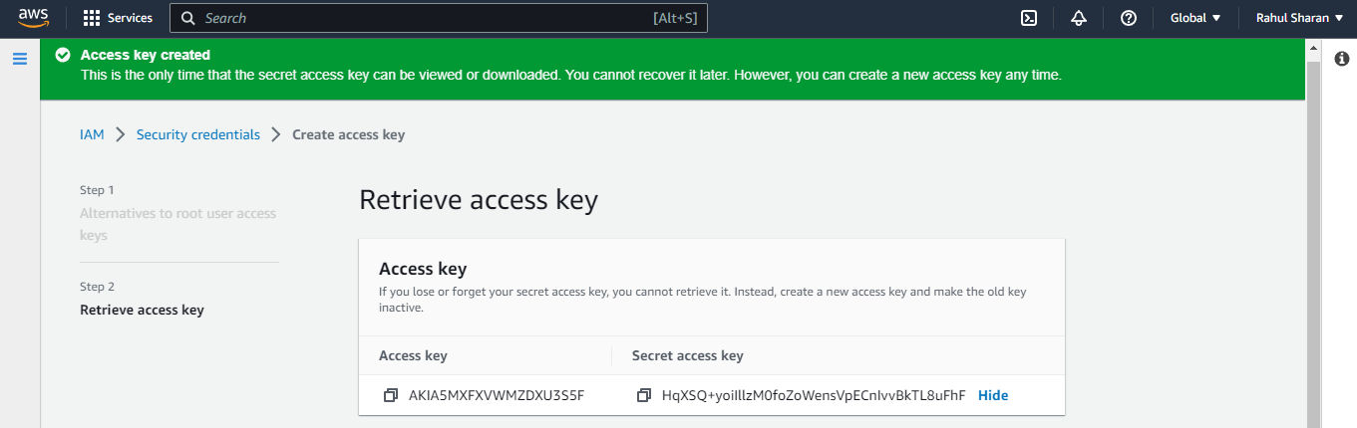

## -Configure the aws access key with terraform on windows:

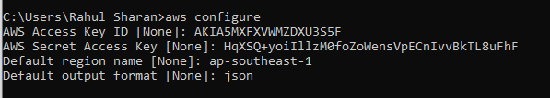

## -Check the created .aws folder and config and credentials files by using following path:

C:\Users\Rahul Sharan\.aws

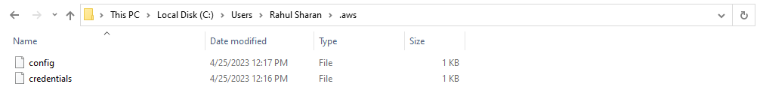

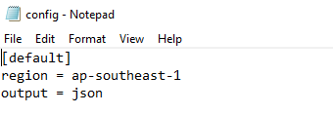

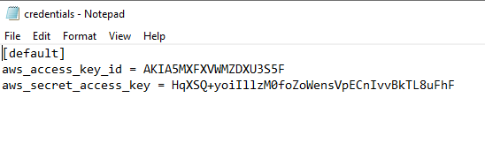

# **To create virtual private cloud by using the Aws Terraform:**

## -Configure the VPC file by using the HCL.

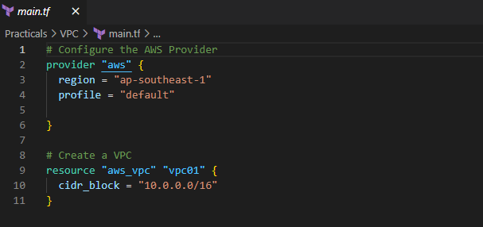

## -Initialize the terraform configuration file using the following command:

>terraform init

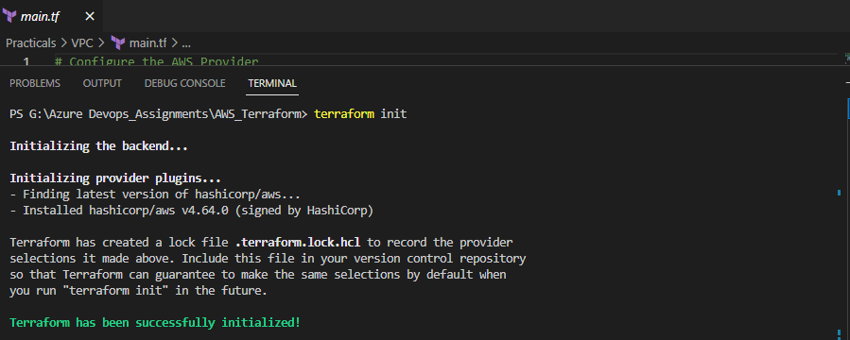

## -Create an execution plan for resource group by using the following command:

>terraform plan –out main.tfplan

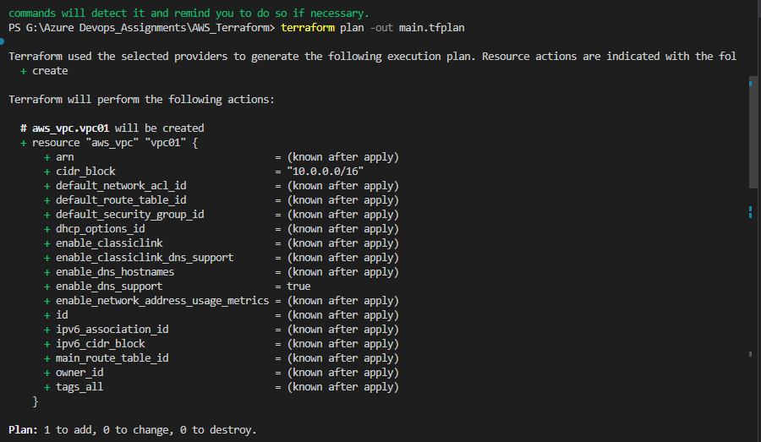

## -Execute the resource group by using the following command:

>terraform apply

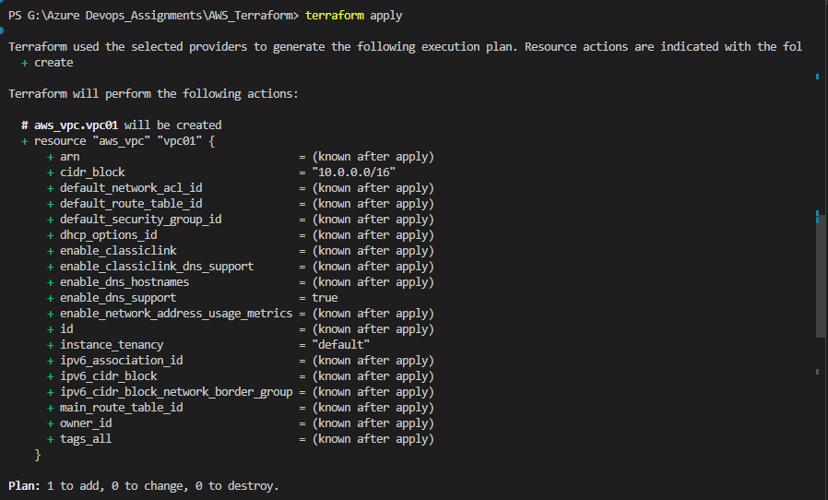

## -Verify the VPC in AWS portal:

